DIGIT 3 synthesized Sample Images

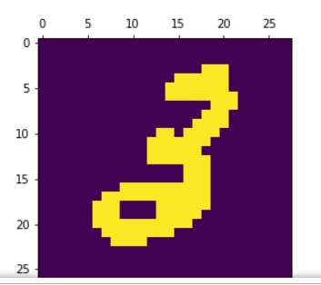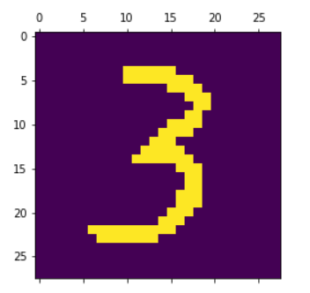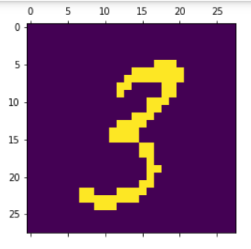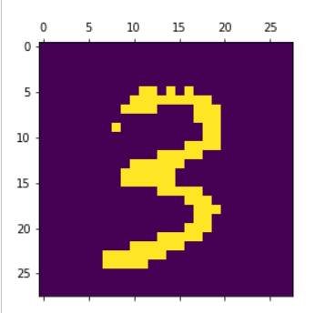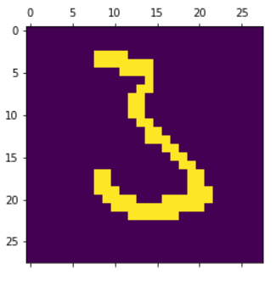

DIGIT 5 synthesized Sample Images

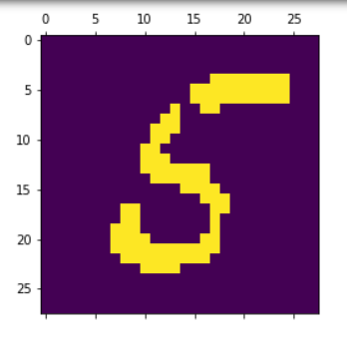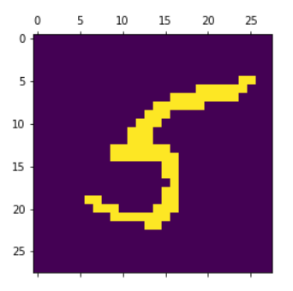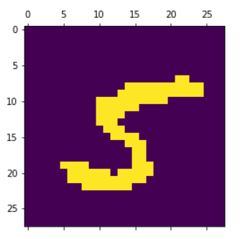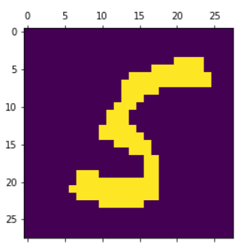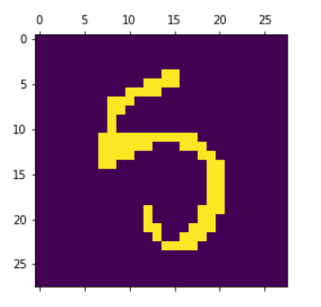

Code

def IMAGE_SMOTE(df , sample):

n = df.shape[0]

for i in range(sample):

j = np.random.randint(0, n, 1)

k = np.random.randint(0, n, 1)

x = df.iloc[j,:].values

y = df.iloc[k,:].values

x_hat = ((x - y ) * np.random.sample(1)) + x

x_hat = np.array([0 if i<=150 else 1 for i in np.ravel(x_hat)])

plt.matshow(x_hat.reshape(28,28))

plt.show()